HRSP

Historic Revitalization Subgrant Program
Rehabilitation of Commercial Structures in Louisiana’sMain Street Districts

This project is supported through a grant from the Historic Revitalization Subgrant Program as administered by the National Park Service, Department of Interior.

Things to know before you apply:
1. In order to be eligible, your property must meet all of the following Louisiana Main Street requirements:
- It must be a commercial property. For the purposes of this grant, a commercial property is defined as a property that is not the residence of the applicant. Properties such as apartment buildings or buildings that have commercial spaces on the ground floor and residential spaces on the upper floor(s) are eligible.

- It must be located within a designated Louisiana Main Street district.

2. In order to be eligible, your property must also meet all of the following National Park Service requirements:

- Eligible properties include historic districts, buildings, sites, structures and objects listed or eligible for listing in the National Register of Historic Places located in communities with less than 50,000 population as determined by the US Bureau of the Census.

- If properties are eligible for listing (not already listed in the National Register of Historic Places) and if they receive funding, a nomination to the National Register of Historic Places must be completed and submitted to the Louisiana National Register Review Committee as part of the project.

- All work must meet the Secretary of the Interior’s Standards for Rehabilitation.

- All properties receiving funding must enter into a preservation easement agreement with the Louisiana Trust for Historic Preservation. The term of the agreement is a minimum of 10 years as determined by the amount of the subgrant. A sample easement may be found in Appendix C of this document.
3. The priority of this grant program is to return currently vacant or under-utilized historic buildings into productive use. As part of the grant process, you will be required to outline the planned intended use for the building after the revitalization project has been completed.
4. All applications will be scored by a panel of Main Street professionals located out of state. The final panel score will then be weighted by a factor related to the fulfillment of your community’s attendance at required Louisiana Main Street meetings during the calendar year prior to the grant cycle.

Guidelines for Application and Grant

The Historic Revitalization Subgrant Program (HRSP) will provide funds to encourage the revitalization of historic downtown commercial properties located in designated Louisiana Main Street districts in communities with less than 50,000 population. The HRSP will serve as an effort to promote community revitalization and stimulate economic growth and vitality, in addition to enriching cultural tourism. Community reinvestment utilizing historic preservation practices improves community economic health by fostering renewed interest in shopping, working, and living downtown.
The HRSP is funded by the Historic Preservation Fund (HPF) and the National Park Service (NPS). The total amount available for all subgrants funded by the HRSP is $660,000. HPF and the NPS will fund $600,000 of the total and the State of Louisiana (State) will provide an additional $60,000. Twelve grants in the amount of $55,000 each will be awarded. Grant recipients will be required to provide a $5,000 match. Grants will be awarded in two rounds with 6 grants awarded in each round.
Priority for funding will be given to historic properties that are currently under-utilized (less than 50% occupied) or vacant, and that, but for this grant, would remain under-utilized or vacant. A specific plan of action for the proposed use of the building after completion of work funded by this grant must be included in the application.
The grant selection process, including evaluation criteria, is outlined in Appendix A of this document.

Deadline:Grant applications must be postmarked for delivery to Louisiana Main Street no later than March 31, 2020 for the first grant cycle and no later than March 31, 3021 for the second grant cycle. The following addresses must be used for delivery:
Overnight Commercial Delivery: U. S. Postal Service Delivery:
Ray Scriber Ray Scriber
Louisiana Main Street Louisiana Main Street
1051 North 3rd Street, Suite 405 PO Box 44247
Baton Rouge, LA 70802 Baton Rouge, LA 70804

Matching Funds:This grant requires a $5,000 monetary match toward hard costs. Matching dollars must be used for actual construction/restoration hard costs only. Contributions of design work or other sweat equity, equipment, etc., are encouraged, but regarded as in-kind and cannot be used as fulfillment of the match requirement for the purpose of this grant.
This is a reimbursement grant: The grant award will be paid only upon completion of the work described in the approved scope of work that will be outlined in the grant agreement to be executed upon selection of the grant recipients. All grant-funded work must comply with:
- The scope of work outlined in the grant agreement
- The Secretary of the Interior’s Standards for Rehabilitation
- All provisions of the grant agreement
Standards: Applicants and construction professionals are strongly encouraged to become familiar with The Secretary of the Interior’s Standards for Rehabilitation. They are available at the National Park Service’s website: https://www.nps.gov/tps/standards.htm
Additional guidance may be found in the National Park Service Preservation Briefs at:
https://www.nps.gov/tps/how-to-preserve/briefs.htm
Issuance of a Certificate of Appropriateness (COA) by your local historic district commission does not guarantee that the proposed scope of work meets The Secretary of the Interior’s Standards for Rehabilitation.Louisiana Main Street may amend the proposed scope of work to ensure compliance with the Standards. Amendments to the scope may necessitate a new review by the local historic district commission and a new COA.
Tax Liabilities:Grant recipients are responsible for any income tax liability incurred as a result of receiving grant funds. Recipients will receive an IRS Form 1099-MISC, Miscellaneous Income for use in preparing tax returns for the year in which the grant payment is issued.
Project Review Prior to Start of Construction:Grant recipients must meet with Louisiana Main Street staff or its designated representatives at the building site to discuss the Scope of Work and any design needs prior to beginning of construction.
Regulations: All grants must follow Office of Management and Budget (OMB) regulations in Title 2, Part 200 of the Code of Federal Regulations (2 CFR 200). These regulations may be viewed at: https://ecfr.io/Title-02/cfr200_main. In addition, grants must follow the regulations in the Historic Preservation Fund Manual which may be viewed at:https://www.nps.gov/preservation-grants/manual/HPF_Manual.pdf.

Who May Apply
- Property owners or tenants of commercially-zoned properties located within designated Louisiana Main Street districts in communities with less than 50,000 population according to the U. S. Bureau of the Census.

  - Tenants must obtain on the grant application the property owner’s signature of consent to the proposed scope of work.
  - If the applicant is a corporation or non-profit organization, the grant application must be accompanied by a resolution from the board of directors authorizing the signer of the application on behalf of the corporation or non-profit.
  - If the applicant is a co-owner of the property, the grant application must be accompanied by a statement signed by all co-owners authorizing the applicant to act on behalf of all co-owners.

- Buildings must be individually listed in the National Register of Historic Places or determined to be eligible for listing in the National Register of Historic Places (eligibility to be determined by the Louisiana State Historic Preservation Officer).
- or -
Identified as a contributing element to a district listed in the National Register of Historic Places or certified to be contributing to a National Register district listing (certification to be determined by the Louisiana State Historic Preservation Officer).

What is Funded
- Exterior Work: The scope of work must directly contribute physically (visually and with regard to historic preservation) and economically to the revitalization of the Main Street district while preserving and respecting the historic architectural character of the building and district as well as the architectural heritage of the community.

- All proposed work to the exterior of the building must be approved by the local historic district commission prior to beginning of construction. Proposed exterior work must comply with The Secretary of the Interior’s Standards for Rehabilitation.

- Interior Work: Improvements are restricted to exposing, restoring, or replicating original interior architectural features. Proposed work to the interior of the building does not require approval by the local historic district commission, however, all work must comply with The Secretary of the Interior’s Standards for Rehabilitation.

What is Not Funded
- Properties that are zoned residential and properties housing home-based businesses within the Main Street district.
- Work that is considered to be general maintenance
- RHINO paint and other coatings that permanently bond with historic materials.

- Work using EIFS and Drive-It (or comparable) materials.

- Replacement of restorable historic wood doors and windows.

- Exterior siding and decorative elements that are non-historic or historically inappropriate in both material and design.

- Landscaping, streetscaping, parking lots, paving, fences, and gazebos.

- The addition of balconies to the publicly-visible façade of buildings unless historic documentation is provided to prove that the building historically had a balcony in the proposed location.

- Furniture, fixtures, and equipment (interior or exterior).

- Electronic security systems.

- Exterior security measures that detract from the historic character of the building, such as burglar bars or roll-up grills.

Grant Amounts
Grant awards will be in the amount of $55,000. Of the total, $50,000 will be funded by the National Park Service Historic Preservation Fund and $5,000 will be funded by Louisiana state general fund dollars. Grants require a $5,000 or more match by the applicant.
Local Historic District Commission
The proposed scope of work must be reviewed by and approved by the local historic district commission for exterior work only. Approval of an application for a Certificate of Appropriateness may be made by the local historic district commission after submission of the grant application, but an approved Certificate of Appropriateness must be presented to Louisiana Main Street prior to the start of work.
When applying for a Certificate of Appropriateness, the local historic district commission must be made aware of the grant application and the grant requirement that all work must comply with The Secretary of the Interior’s Standards for Rehabilitation.
Work on the interior of a building does not have to be reviewed by the local historic district commission and an approved Certificate of Appropriateness is not required for interior workhowever, all work must comply with The Secretary of the Interior’s Standards for Rehabilitation.

Grant Compliance
Work funded by the grant may not begin until the grant agreement with the State of Louisiana, Department of Culture, Recreation and Tourism, Office of Cultural Development is signed by all parties.
Grant-funded work may be a portion of a larger-scale in-progress project. However, grant recipients are only eligible to receive reimbursement for work outlined in the scope of work of the grant agreement. All grant-funded work must be completed within the term of the grant agreement. Reimbursement is not retroactive for work already underway or already completed at the time the grant agreement is signed.
Failure to commence work within 45 days of receiving a fully-signed copy of the grant agreement will void the grant.
Grant funded project work must be completed by the deadline as outlined in the grant timeline contained in Appendix B.

How to Apply
Contact your local Main Street director to:
- Determine if the building is located within the boundaries of the Main Street district
- Determine the status of the building in the National Register of Historic Places
- Determine if the project requires an approved Certificate of Appropriateness from the local historic district commission.
- Determine the process for obtaining an approved Certificate of Appropriateness from the local historic district commission.
- Request a map of the Main Street district showing the district boundaries and the building’s location within those boundaries.

Submit a complete application, along with a copy of the approved Certificate of Appropriateness (if you have received one) and other supplemental materials, to your local Main Street director. Your local director will advise you of the deadline for submitting all material to the local Main Street office.

Incomplete applications will not be accepted.

The checklist pages of the application must be included in the application packet.

Both the applicant and the local Main Street director are required to sign the application checklist pages.

The local Main Street director will submit all completed application packets to the Louisiana Main Street office by the deadline as outlined in the grant timeline contained in Appendix B.

Selection Process
Upon receipt, the local Main Street director will review the application for completeness and compliance. If the application is complete with all requested information, and if the building meets the grant qualifications listed in the Who May Apply section, the application and all supporting documents will be submitted to Louisiana Main Street by the deadline stated in Appendix B.

Incomplete applications and applications for buildings that do not meet the qualifications will not be accepted for review by the panel.
Accepted applications will be scanned and entered into the Louisiana Main Street online panel scoring process.

Panelists are professionals selected from the fields of architecture, construction, historic preservation, economic development, and other associated areas of community revitalization specialization from around the country. In order to maintain impartiality, panelists cannot be employed by a Louisiana Main Street community, cannot reside in a designated Louisiana Main Street community, cannot be an employee of the Louisiana Department of Culture, Recreation and Tourism, cannot be an employee of Louisiana Economic Development, and cannot be directly or indirectly involved with Louisiana Main Street communities.
Note: Members of the review panel will not be familiar with the buildings or settings
associated with the applications. It is vital that your application communicates visually
through photographs and in writing through the narrative so that panelists can know as
much as possible about the importance of the project to your community.

Panelists will review each application based on the criteria outlined in Appendix A and will each individually assign a score to every application through an online process. The process will result in a total score for each application.
Louisiana Main Street will apply a weighting factor to each application’s total score. Scores will be weighted by the local Main Street program’s percentage of attendance at required meetings during the calendar year immediately prior to the grant cycle. Examples: If the local Main Street program attended 100% of the required-attendance meetings, then the grant application will receive 100% of the panel score. If the local community only attended 40% of the required-attendance meetings, then the application will receive 40% of the panel score.
Louisiana Main Street will rank all grant applications based on the weighted scores.
In each grant round, the six highest-ranked applications will be selected for funding based on one grant per community.

Competition
It is anticipated that this will be a highly competitive grant application. Regrettably, not every applicant can be assured of receiving a grant. Award considerations include, but are not limited to:
- The level of restoration of the intended project.
- The impact of the project on the original building design.
- The economic impact the completed project will bring to the commercial district.
- The visual impact the completed project will bring to the commercial district and to the local Main Street experience.
- The availability of funds appropriated by the Louisiana Legislature to fund the state’s $5,000 portion of the grant. Award amounts may be adjusted contingent on legislative allocation of funds.

Reimbursement
By submitting a grant application, the applicant is indicating an intention to do the work as proposed and has the financial resources in place to begin and complete the work as stated.
Reimbursement will be made to the grant recipient in one lump sum payment upon completion of the project and after on-site inspection by Louisiana Main Street or its representatives. On-site inspection will determine whether or not all work has been done in compliance with the terms of the grant agreement.
The following items shall be submitted to Louisiana Main Street in order to receive grant funds:
- Reimbursement Request Form (included in grant documents after selection) detailing the final project costs and signed by the grant recipient.
- Digital photographs documenting the completed project
- Spreadsheet of expenses along with dated copies of contractor invoices or receipts for purchase of materials along with scanned images of payment checks. The documented expenses should be equal to or greater than the total of the grant award plus the required cash match.
- Reimbursement will be paid to the entity that enters into the grant agreement.

Application Checklist

I have reviewed this checklist and confirm that all requested items are included with the application:
Applicant Main Street Director

This Checklist Must Be Included In the Application Packet
(Please place a check mark beside each item that is included with the application)
- Application form:
A completed and signed application form

Documentation that all necessary funds are in place so that work can beginand endaccording to deadlines outlined in Appendix B. (Bank statements are not necessary. Merely note in the narrative that resources are in place to begin your project no later than 45 days after signing and returning the grant agreement if your project is selected for a grant award.)
A board resolution or authorization from co-owners, if applicable. If not applicable, place N/A in the box.
- Certificate of Appropriateness:
A copy of the signed/approved and dated Certificate of Appropriateness is required for all exterior work only. A Certificate of Appropriateness is not required for interior work. In light of time constraints, Louisiana Main Street will allow applications to be submitted prior to the issuing of a COA, but applicant must obtain an approved COA and submit it to the Louisiana Main Street Design Coordinator prior to the start of work.
A Certificate of Appropriateness has not yet been secured from the historic district commission. The COA will be provided after the commission next meets on:

- Digital Photographs:
Documentation of existing condition(s) associated with the scope of work.
Digital photos of the building as it relates to neighboring structures and the streetscape.
Digitally scanned images of historic photos, if available.
NOTE: All photographs accompanying the application must be digital,must be saved as individual JPGs, and must be of good quality. Photographic color prints and slides will not be accepted. Materials will not be returned. Historic photos are very helpful, but only digital copies should be submitted.
- Map:
A map of the entire designated Main Street district showing district boundaries and location of the property associated with the grant. The map can be obtained from the local Main Street director.

- Schematic drawings:

Drawings/renderings of the exterior or interior of the building that illustrate all proposed renovation details associated with the grant scope of work.

Drawings/renderings must be architectural in nature. It is not required that they be prepared by an architect, but should be prepared by someone who can properly illustrate the proposed work in a professional manner. Awning, signage, construction/engineering companies also have the capabilities to provide appropriate drawings with their bids for work. In some cases the local historic district commission and/or Louisiana Main Street may require samples of proposed materials.

For projects not involving architects, applicants are strongly encouraged to utilize the free design services of Louisiana Main Street for the preparation of these renderings. These are also helpful for the historic district commission review. Applicants should schedule time with the design staff early to better ensure the application includes quality illustrations and to receive design advice prior to submitting to the historic district commission.
- Narratives:

While the proposed scope of work will consist of bulleted details, the narratives should state the reasons for why the project should receive grant funding. The application review panelis not familiar with the buildings or towns associated with the projects. The narratives provide understanding of the project, significance of the property to the district, and the impact the work will have on the district.

- Scope of Work:

This is a contractor’s detailed breakdown of project tasks, materials, and itemized costs (not one total cost) for which grant funding is requested.

- Contractor Estimates:
Estimates from contractors must be copies of original, signed, and dated detailed/itemized contractor estimates. Projected costs of materials and labor must be broken out with costs associated with each portion of the project as described in the scope of work.

Please list any additional support documentation included in this packet:

Application

Historic Revitalization Subgrant Program
Rehabilitation of Commercial Structures in Louisiana’s Main Street districts

Application must be legible. Please either type or print.
Applicant Information

Applicant Name:

Applicant MailingAddress:
Street Address:
City, State, ZIP:

Applicant E-Mail Address:

Applicant daytime telephone number:

Does the applicant own the building? Yes No
If no, who owns the building?

Note: BOTH owner and applicant must sign the application.

Is the applicant a building tenant? Yes No

Building Information

Building name:

Building Address:
Street Address:
City, State, ZIP:

Type of building: Commercial Residential Mixed-use

Current use of building:

Percentage of building currently occupied and used commercially:

Percentage of building currently unoccupied and used commercially:

Has this property received a grant from Louisiana Main Street in the past? Yes No
If so, for what work and in what amount?
Provide a narrative that describes the current state of the building, the current use, and the proposed use for the building.

Why should this project receive grant funding through the Historic Revitalization Subgrant Program? How will the completed project impact the local Main Street district?

Note in bullet-point fashion all work to be performed with grant funds, including the dollar amount associated with each and a total. Include copies of signed/dated contractor estimates. Additional pages may be included if necessary.
Scope of Work
  - $ ___________
  - $ ___________
  - $ ___________
  - $ ___________
  - $ ___________
  - $ ___________
  - $ ___________
  - $ ___________
  - $ ___________
  - $ ___________
  - $ ___________
  - $ ___________
  - $ ___________
  - $ ___________
  - $ ___________
  - $ ___________
  - $ ___________

Total $ ____________
Scope of Work Narrative
Please provide a narrative that explains the proposed scope of work, its necessity, and its impact on the building.
When replacing doors, windows, railings, canopies, or other architectural components that are too deteriorated to repair, applicants must provide specific details regarding those replacements. See Secretary of the Interior Standards for Rehabilitation for further clarification or contact the Louisiana Main Street office. Manufacturer tear sheets are helpful and can be obtained from a product sales person or sales representative.

Local Main Street Organization
________________________________________ Main Street was represented at the following mandatory meetings:

_____ Winter Meeting, Franklin – January 2019

_____ Spring Meeting/Louisiana Preservation Conference, Baton Rouge – May 2019

_____ Main Street Now Conference, Seattle, WA – March 2018

_____ Fall Meeting/Destination Downtown Conference, Hammond – September 2019

_____ Total meetings attended / 4 = _______% mandatory meeting attendance

Louisiana House District #:
Representative:

Louisiana Senate District #:
Senator:

U.S. Congressional District #:
Representative:
I have reviewed this applicant’s grant packet and determined it is complete according to the provided checklist.

If this applicant is awarded funding, I will be actively engaged in this project by personally monitoring and documenting the progress of this project for adherence to the scope of work approved by Louisiana Main Street as noted in the grant agreement and with respect to SOI Standards for Rehabilitation. I will report to Louisiana Main Street on a quarterly basis and will keep the grant recipient aware of important dates so he/she remains in compliance with the grant agreement.

Local Main Street director’s signature:

Date:

Applicant Signature Page
By signing the application, the applicant certifies that he/she has read and understands all information contained in the Historic Revitalization Subgrant Program Guidelines and that all figures, statements, and representations made in this application, including any attachments, are true and correct to the best of the applicant's knowledge and that funding is available to proceed with and complete the project per the grant guidelines.

Applicant Signature:

Date:

Please print name:

Building Owner Signature (if building is not owned by applicant):

Date:

Please print name:

Appendix A
Selection Process/Evaluation Criteria
Upon receipt, the local Main Street director will review the application for completeness and compliance. If the application is complete with all requested information, and if the building meets the grant qualifications listed in the Who May Apply section, the application and all supporting documents will be submitted to Louisiana Main Street by the deadline stated in Appendix B.

Incomplete applications and applications for buildings that do not meet the qualifications will not be accepted for review by the panel.

Accepted applications will be scanned and entered into the Louisiana Main Street online panel scoring process.

Panelists are professionals selected from the fields of architecture, construction, historic preservation, economic development, and other associated areas of community revitalization specialization from around the country. In order to maintain impartiality, panelists cannot be employed by a Louisiana Main Street community, cannot reside in a designated Louisiana Main Street community, cannot be an employee of the Louisiana Department of Culture, Recreation and Tourism, cannot be an employee of Louisiana Economic Development, and cannot be directly or indirectly involved with Louisiana Main Street communities.
Note: Member of the review panel will not be familiar with the buildings or settings
associated with the applications. It is vital that your application communicates visually
through photographs and in writing through the narrative so that panelists can know as
much as possible about the importance of the project to your community.

Panelists will review each application based on the criteria outlined below and will each individually assign a score to every application through an online process. The process will result in a total score for each application.
Louisiana Main Street will apply a weighting factor to each application’s total score. Scores will be weighted by the local Main Street program’s percentage of attendance at required meetings during the calendar year immediately prior to the grant cycle. Examples: If the local Main Street program attended 100% of the required-attendance meetings, then the grant application will receive 100% of the panel score. If the local community only attended 40% of the required-attendance meetings, then the application will receive 40% of the panel score.
Louisiana Main Street will rank all grant applications based on the weighted scores.
In each grant round, the six highest-ranked applications will be selected for funding based on one grant per community.

Panelists will review each application and provide an overall score in a range of 0 points to 10 points. In addition, panelists will be asked to provide comments and feedback on the following as they relate to the application:
    - Positive Aspects
    - Needs Improvement
    - Supplements
    - General Impressions

Positive Aspects include items such as the completeness of the application, impact of the project on the building, impact on the project in the Main Street district. It also would include how well the scope of work is described and how well the cost of the work is documented.

Needs Improvement will allow the panelists to comment on areas of the grant application that were lacking in the requested information.

Supplements will allow the panelists to provide feedback on the quality and helpfulness of the required supplements, such as maps, historic documentation on the building, current photographs of the building, photographs that help indicate the areas of the building where work is intended, detailed scope of work, documented cost estimates, etc.

General Impressions will be indicative of an overall review of the application and the impact of the project on the economic improvement to the Main Street district.
Appendix B
Grant Timelines

GRANT CYCLE 1
January 2020 - February 2021

January 23-24, 2020 Grant information reviewed with local Main Street directors

Local submission You must check with your local Main Street director to determine the date
deadline by which applications must be submitted to local Main Street office.

March 31, 2020 Applications must be postmarked for delivery to Louisiana Main Street

April – May, 2020 Applications will be reviewed, ranked, selected for funding, grant documents
will be sent to recipients
Note: Applicants must commence implementation of the scope of work within 45 days of receiving a fully-signed copy of the grant agreement. Failure to begin work within 45 days will void the grant.

January 31, 2021 Deadline for completing all items listed in the grant scope of work

February 28, 2021 Deadline for submitting reimbursement requests

GRANT CYCLE 2
January 2021 – February 2022

January 28-29, 2021 Grant information reviewed with local Main Street directors
(tentative)

Local submission You must check with your local Main Street director to determine the date
deadline by which applications must be submitted to local Main Street office.

March 31, 2021 Applications must be postmarked for delivery to Louisiana Main Street

April – May, 2021 Applications will be reviewed, ranked, selected for funding, grant documents
will be sent to recipients
Note: Applicants must commence implementation of the scope of work within 45 days of receiving a fully-signed copy of the grant agreement. Failure to begin work within 45 days will void the grant.

January 31, 2022 Deadline for completing all items listed in the grant scope of work

February 28, 2022 Deadline for submitting reimbursement requests

Appendix C
Sample Easement

LOUISIANA

ST. JOHN THE BAPTIST PARISH

HISTORIC CONSERVATION SERVITUDE

THIS AGREEMENT, made this the _th day of ________ 2019, by and between _______________, ofOrleans Parish, Louisiana and ______________, of St. John the Baptist Parish, Louisiana (hereinafter referred to as the "Grantors" and “Owners”), and LOUISIANA PRESERVATION ALLIANCE, INC. (dba: Louisiana Trust for Historic Preservation), a non-profit corporation organized and existing under the laws of the State of Louisiana with its principal office being in Baton Rouge, Louisiana (hereinafter referred to as the "Foundation");
W I T N E S S E T H:
WHEREAS, the Grantors own certain real property (historically known as “SORAPURU HOUSE” and located at the mailing address of _____________________ and hereby referred to as “SORAPURU HOUSE”) a description of which is attached hereto as Exhibit "A" and incorporated herein by reference; and
WHEREAS, the Subject Property currently has certain permanent improvements consisting of a one-story house constructed ca. 1825, hereinafter referred to as SORAPURU HOUSE; and
WHEREAS, SORAPURU HOUSE, Edgard, St. John the Baptist Parish, Louisiana, is a building of recognized historical, architectural and/or cultural significance and listed on the National Register of Historic Places; and
WHEREAS, the Foundation and Grantors both desire that SORAPURU HOUSE be adapted and altered, where necessary, to provide for contemporary uses, while at the same time retaining its historically and architecturally significant features; and
WHEREAS, The Foundation and Grantor both desire that SORAPURU HOUSE be preserved in a state which will preserve its integrity; and
WHEREAS, The SORAPURU HOUSE is a historic record of the importance and cultural contributions to Louisiana of both the Sorapuru Family and Free People of Color; and
WHEREAS, the Foundation is a charitable organization which accepts conservation servitudes on buildings having historical or architectural importance, said servitude subjecting such buildings to restrictions that will insure that they are preserved and maintained for the benefit of future generations; and

WHEREAS, the Louisiana State Legislature has enacted the Louisiana Conservation Servitude Act (LCSA), (RS 9:1271-1276), validating restrictions, conservation servitudes, covenants, conditions, or otherwise, appropriate to the preservation of a structure or site significant for its historical, archaeological, or cultural aspects.
NOW, THEREFORE, for and in consideration of the Grantors' interest in historic preservation and their support for the Foundation and its purposes, and for and in consideration of the sum of ONE DOLLAR ($1.00), the Grantors, for themselves, their successors and assigns, hereby grant conservation servitudes and agree to abide by the following restrictions (hereinafter referred to as "covenants"), said covenants to be restrictions of record to attach to the land described in Exhibit A.
1. These covenants shall be administered solely by the LOUISIANA PRESERVATION ALLIANCE, INC., its successors in interest or assigns; and in all subsequent conveyances of Subject Property, the Foundation, its successors in interest or assigns shall be the sole party entitled to administer these covenants. In the event that the Foundation, or its successors in interest by corporate merger cease to exist, then in such event the Foundation shall assign all of its rights and interests in these easements, covenants, and conditions subject to such duties and obligations which it assumes hereby to a non-profit corporation of responsibility which exists for substantially the same reasons as the Foundation itself (as described hereinabove); if no such corporation be available for such assignment, then under such circumstances such assignment shall be made to the State of Louisiana which shall be the sole party entitled to administer these covenants.
Maintenance
2. The Grantors covenant and agree to continuously maintain, repair, and administer the subject property herein described in accordance with the Secretary of the Interior's Standards for the Treatment of Historic Properties (in effect as of 1992) so as to preserve the historical integrity of features, materials, appearances, workmanship and environment of the subject property. Maintenance shall be continuously provided using in-kind materials and workmanship. Said standards are attached as ExhibitC hereto and incorporated in these covenants by reference.
Prior Approval Required for Modifications
3. No change in use of SORAPURU HOUSE may be made without prior written approval of the Foundation. No disturbing of soil without prior consent of the Foundation, in an effort to preserve the archaeological record of the site.
4. No alteration, no physical or structural change and no changes in the material or surfacing shall be made to the exterior of SORAPURU HOUSE without the prior written approval of the Foundation. Historic documentation (photographs, drawings/paintings, surveys, letters and other documents, where verified) shall guide the design intent on replacement of missing architectural features.
5. No addition to an existing building nor any additional structure or site feature shall be built upon the subject property unless the plans and exterior designs for such structure or addition have been approved in advance in writing by the Foundation. The Foundation in reviewing the plans and designs for any addition or additional structure shall consider the following criteria:
Exterior building materials; height; fenestration; roof shapes, forms, and materials; surface textures; expression of architectural detailing; scale; relationship or any additions to the main structure; general form and proportion of structure; orientation to street; setback; spacing of buildings, defined as the distance between adjacent buildings; lot coverage; use of local or regional architectural traditions; and effect on landscape and archeological resources. Contemporary designs for additions or additional structures shall not be discouraged when such alterations and additions do not destroy significant historical, architectural, or cultural material, and such design is compatible with the size, color, material and character of the property and its environment.

Foundation conveys and Grantor accepts the subject property “as is” and with all faults, and Foundation disclaims all express warranties, other than the special warranty of title contained herein, all statutory warranties, an all implied warranties, with respect to the subject property, and, as to fixtures thereon or improvements thereto conveyed hereby, if any, disclaims all warranties of habitability, merchantability or fitness for a particular purpose or use to the greatest extent permitted by law. Grantor is relying solely on their own expertise and that of its consultants in purchasing the property. Grantor has conducted such inspections and investigations of the property as they deem necessary, and are relying on same. Grantor assumes the risk that adverse matters, including but not limited to adverse physical and environmental conditions, may not have been revealed by their inspections and investigations. Grantor further acknowledges and agrees that there are no oral agreements, warranties or representations, collateral to or affecting the property by Foundation (other than disclosures required by law, which required disclosures are not to be given any weight, meaning or purpose beyond that expressly required by law), any agent of Foundation or any third party, and that Foundation is not liable or bound in any manner by any oral or written statements, representations, or information pertaining to the property furnished by any real estate broker, agent, employee, servant or other person, unless the same are specifically set forth or referred to herein. Grantor further acknowledges and agrees that the provisions were a material factor in the determination of the purchase price for the property.
Rehabilitation Plan
Within thirty (30) days before beginning any rehabilitation work (including the removal of historic material), Owner shall submit to Foundation a rehabilitation plan for review and consideration for approval. The rehabilitation plan, including any amendments thereto shall consist of all documents, drawings, and reports, if any, required by applicable laws, ordinances and regulations to be submitted by Owners to any governmental or regulatory authority to obtain any license, permit or other approval required for the Rehabilitation Work. In the absence of such regulating authority, Owner shall provide such documents, drawings and reports sufficient to illustrate the modifications to the property, including modifications to the interior, exterior and site.
Within thirty (30) days of receipt of the rehabilitation plan documents, Foundation shall approve or disapprove the rehabilitation plan and any amendment thereto within fifteen (15) days of receipt of same from Owner. Approval or disapproval shall be sent via certified mail to the Grantee within this time period. Any disapproval shall state specifically the reason for the disapproval. Failure by Foundation to disapprove the rehabilitation plan or any amendment thereto within the above-stated time periods shall not be deemed Foundation’s approval of the same. Foundation shall not unduly delay review of submitted Rehabilitation Plan.
Rehabilitation Work
All rehabilitation work shall be done in accordance with such rehabilitation plan as approved by Foundation. Such rehabilitation work shall commence within sixty (60) days from receipt of approval from Foundation and shall be completed on or before eighteen (18) months from the date of commencement and within 24 months of acquisition. All work shall be at Owner’s sole cost and expense; shall be done in a good and workmanlike manner using new materials or with salvaged materials approved by Foundation; shall not result in any liens or claims to be filed or asserted against the Property or any portion thereof; shall have had all necessary licenses and permits issued in connection therewith; and shall be completed in a manner otherwise satisfactory to Foundation. Owner is to notify Foundation at the point of substantial completion to coordinate a site visit to document the work and insure its completion in accordance with the approved rehabilitation plan.

6. Neither SORAPURU HOUSE nor any part thereof may be removed or demolished without the prior written approval of the Foundation.
7. The Grantors and the Foundation hereby agree that the character-defining features listed below are elements which contribute to the architectural significance of SORAPURU HOUSE and should therefore be maintained and protected:
Interior:
- Four Federal mantels of the same style and detail
- Early (pre-1900) wood doors, wood windows, hardware, trim, picture rails
- Early (pre-1900) wood floors and raised thresholds
- Ceilings of beaded boards and beams in both “tray” and “coffered” configuration
- Plaster over bousillage construction with limewash finish
Exterior:
- Wood siding, trim, windows and shutters
- Wood railing and columns on front porch

Recommendations: Foundation would favor the removal of existing brick steps at front porch. New vinyl or other synthetic siding or exterior storm windows or doors may not be installed.
8. No portion of the acreage under covenant with the subject property may be subdivided.
9. The Grantors shall abide by all federal, state and local laws and ordinances regulating the rehabilitation, maintenance and use of the subject property.
10. No living trees greater than 12 inches in diameter at a point 4 feet above the ground shall be removed from the Subject Property without the express written approval of the Foundation unless immediate removal is necessary for the protection of any persons coming on to the Subject Property or of the general public; or for the prevention or treatment of disease; or for the protection and safety of SORAPURU HOUSE or any other historic permanent improvements on the Subject Property. Any tree of the aforementioned size which must be removed shall be replaced within a reasonable time by a new tree or a substantially similar species. If so requested, the Foundation may approve the use of an alternate species. Nothing shall be erected or allowed to grow on the Subject Property which would impair the visibility of the property and the buildings from the street level or other public rights of way.
Sale of the Property
11. In case of any contemplated sale of the subject property or any portion thereof by the Grantors or any successor in title thereto, first refusal as to any bona fide offer of purchase must be given to the Foundation, its successors or assigns. If the Foundation so decides to purchase, it shall notify the then owner of its willingness to buy upon the same terms within ten (10) days of receipt of written notice of such bona fide offer. Failure of the Foundation to notify the then owner of its intention to exercise this right of first refusal within such ten (10) day period shall free the owner to sell pursuant to the bona fide offer. Provided, however, that if there are any outstanding deeds of trust or other encumbrances against the property, any right to repurchase shall be subject to said deeds of trust or encumbrances, and they shall either be satisfied or assumed as part of the purchase price.
12. Owners may notify Foundation of their intent to offer the property for sale prior to its advertisement or listing for sale, so that the Foundation may choose to provide assistance to the owner and/or realtor in locating potential buyers who will continue to protect and maintain the historic character of the property.

Access to Property
13. Representatives of the Foundation shall have the right to enter the subject property at reasonable times, after giving reasonable notice, for the purpose of inspecting and documenting the building and grounds to determine if there is continued compliance by the Owners with the terms of these covenants.
14. Researchers, scholars, and groups especially interested in historic preservation shall have access to view the interior of the rehabilitated property by special appointment at various times and intervals.
Insurance and Mortgage Holders
15. Grantors shall insure the subject property against damage by fire or other catastrophe. If the original structure is damaged by fire or other catastrophe to an extent not exceeding fifty percent (50%) of the insurable value of those portions of the building, then insurance proceeds shall be used to rebuild those portions of the subject property in accordance with the standards in Exhibit B. The Grantors shall keep the subject property insured under a comprehensive general liability policy that names the Foundation as an additional interest and that protects the Grantors and the Foundation against claims for personal injury, death and property damage.
16. All mortgages and rights in the property of all mortgagees are subject and subordinate at all times to the rights of the Foundation to enforce the purposes of this Historic Preservation Agreement. Grantors will provide a copy of this Agreement to all mortgagees of the subject property and have caused all mortgagees as of the date of this Agreement to subordinate the priority of their liens to this Agreement. The subordination provisions as described above relates only to the purposes of the Agreement, namely the preservation of the historic architecture and landscape of the Subject Property.
Extinguishment
17. The Grantors and the Foundation recognize that an unexpected change in the conditions surrounding the Subject Property may make impossible or impractical the continued use of the Subject Property for conservation purposes and necessitate the extinguishment of this Historic Preservation Agreement. Such an extinguishment must comply with the following requirements:
(a) The extinguishment must be the result of a final judicial proceeding.
(b) The Foundation shall be entitled to share in the net proceeds resulting from the extinguishment in an amount in
accordance with the then applicable regulations of the Internal Revenue Service of the U.S. Department of the Treasury.
(c) The Foundation agrees to apply all of the portion of the net proceeds it receives to the preservation and
conservation of other property or buildings having historical or architectural significance to the people of the State of Louisiana.
- Net proceeds shall include, without limitation, insurance proceeds, condemnation proceeds or awards, proceeds from a sale in lieu of condemnation, and proceeds from the sale or exchange by Grantors of any portion of the Subject Property after the extinguishment.

18. Unless otherwise provided, the conservation servitudes and restrictions set forth above shall run in perpetuity and shall terminate and be of no further force or effect only in the event that SORAPURU HOUSE is damaged beyond restoration as a result of fire or other catastrophe. Damage beyond restoration is defined as damage to an extent exceeding fifty percent (50%) of the insurable value of the building. If it is determined by the Foundation to be damaged beyond any reasonable possibility of rehabilitation, the Foundation shall have the right to coordinate salvage of re-usable building materials prior to demolition.
Remedies
19. In the event of a violation of these covenants and restrictions, all legal and equitable remedies, including injunctive relief, specific performance, and damages, shall be available to the Foundation. No failure on the part of the Foundation to enforce any portion of the conservation servitude (covenant) or restriction herein nor the waiver of any right hereunder by the Foundation shall discharge or invalidate such covenant or restriction or any other covenant, condition or restriction hereof, or affect the right of the Foundation to enforce the same in event of a subsequent breach or default.
20. Foundation, its successors and assigns, shall have the right to seek and obtain in any court of competent jurisdiction a restraining order or a temporary or permanent injunction to restrain a violation of any of the restrictions or covenants contained herein. In no event shall any failure by Foundation to seek injunctive relief with regard to any one or more violations of such covenants or restrictions constitute a waiver of Foundation's right to enjoin any other or further violation.
21. Foundation further reserves the right to enforce any restrictions and covenants contained in this Deed by any other appropriate action at its option. Owner shall be responsible for and shall pay Foundation upon demand all costs and expenses, including attorney's fees, of the enforcement by Foundation of any of Owner's obligations or any condition or restriction or covenant under this Deed.
22. WHEREAS, in the event of removal of character-defining featuresoutlined in Paragraph 7, the Foundation then shall have the option to fine the Owner the sum of one hundred ($100.00) dollars per day, after giving written notice of the nature of the violation(s) and the Owner shall not have corrected the same within the ninety (90) days next following the giving of said notice.Such historic features shall be returned to their previous location and state of repair. Where such original elements are damaged beyond feasible use or destroyed, owner shall at their own expense, reproduce such features and install them to replicate the previously documented historic character of the property.
23. Foundation shall further have the right, in addition to all other rights or remedies hereunder or at law or in equity which are available to Foundation in the event of a violation of any of the restrictions or covenants contained herein, to exercise one or more of the following remedies upon or at any time after the occurrence of any such violation:
(i) The right to enter the Property at reasonable times, with five (5) days written notice being considered reasonable notice of intent to enter, to inspect property to determine whether restrictions and covenants contained herein are being carried out.
(ii) The right, subject to the notice and cure periods set forth herein, to enter the Property and complete or remedy the undertaking of the Owner which has been breached or the covenant or restrictions which has been violated. If Owner violate or fail to fully perform any covenant set forth herein which would result in an endangerment to or serious compromising of the structural integrity of any Improvement, Owner shall, within five (5) days of the date of written notice from Foundation, complete temporary cure of same, and shall, within thirty (30) days of the date of the aforesaid written notice from Foundation, commence permanent cure of same, and shall thereafter diligently pursue, and shall within a reasonable time, complete the permanent cure of same. If Owner violates any restriction or condition or fails to fully perform any covenant set forth herein which would not result in any endangerment or compromise referred to in the immediately preceding sentence, Owner shall, within ninety (90) days of the date of written notice from Foundation, commence cure of same, and shall thereafter diligently pursue such cure and complete same within a reasonable time. The Owner, by acceptance of this conveyance, do grant to the Foundation a lien on and against the Property to secure the payment of all costs incurred by the Foundation in the performance or completion and/or performance of the covenant, condition or restriction breached. Such lien shall be subordinate to a first lien securing a loan given to finance the purchase of the Property.
24. Furthermore, in the event of a violation of covenants contained in Paragraphs 2, 3, 4, 5, 6 and 7 hereof, the Foundation shall have an option to purchase the subject property, provided that it shall give the Grantors written notice of the nature of the violation and the Grantors shall not have corrected same within the ninety (90) days next following the giving of said notice. The purchase of the subject property, pursuant to the exercise of the option retained hereby, shall be at a price equal to the then fair market value of the subject property, subject to restrictive covenants, as determined by agreement of the Grantors and the Foundation, or in the absence of such agreement, by a committee of three appraisers, one to be selected by the Foundation, one to be selected by the Grantors, and the other to be designated by the two appraisers selected by the Foundation and the Grantors respectively. Provided, however, that if there are any outstanding deeds of trust or other encumbrances against the property, any right to repurchase shall be subject to said deeds of trust or encumbrances, and they shall either be satisfied or assumed as part of the purchase price.
Easement Plaque
25. Foundation may choose to provide a plaque to identify its role in saving and protecting the historic structure and to serve as a reminder of this conservation servitude agreement and its provisions. When provided, the plaque shall remain mounted in a prominent and visible location near the primary entry. The plaque shall remain property of Foundation and shall only be temporarily removed for maintenance of the structure and reinstalled immediately following completion of the work. The plaque may also be removed by an authorized agent of the Foundation. Foundation shall be notified by the owner if the plaque becomes damaged or missing.
Transfer Fee
26. Except as otherwise provided herein, there shall be assessed by the Foundation and collected from the purchasers of the Subject Property, or any portion thereof subject these conservation servitudes and restriction, a transfer fee equal to one percent (1%) of the sales price of such property, or any portion thereof. This transfer fee shall be paid to the Foundation and used by the Foundation for the purpose of preserving and protecting the historical, architectural, archaeological or cultural aspects of real property. Such fee shall not apply to inter-spousal transfer, transfers by gift, transfers between parents and children, transfers between grandparents and grandchildren, transfers between siblings, transfers between a corporation and any shareholders in the same corporation who owns ten percent (10%) or more of the stock in such corporation, transfers between a limited liability corporation and any member who owns more than ten percent (10%) of such limited liability corporation, transfers by Will, bequest, interstate succession or transfers to the Foundation (each of these foregoing hereinafter referred to as an “Exempt Transfer”); provided, however, that such fee shall not apply to the first non-exempt transfer of the Subject Property, but shall apply to each “non-exempt” transfer thereafter. In the event of a non-payment of such a transfer fee, the amount due shall bear interest at the rate of 12% (twelve percent) per annum from the date of such transfer, shall, together with accrued interest, constitute a lien on the real property, or any portion thereof, subject to these covenants and restrictions and shall be subject to foreclosure by the Foundation. In the event that the Foundation is required to foreclose on its lien for the collection of the transfer fee, and/or interest thereon, provide for herein, the Foundation shall be entitled to recover all litigation costs and attorney’s fees incurred as such foreclosure, which litigation costs and attorney’s fees shall be included as part of the lien and recoverable out of proceeds of the foreclosure sale. The Foundation may require the purchaser and/or seller to provide reasonable written proof of the applicable sales price, such as executed closing statements, contracts of sale, copies of deeds, affidavits or such other evidence, and purchaser shall be obligated to provide such information within forty-eight (48) hours after receipt of written request for such information from the Foundation.

IN WITNESS WHEREOF, the Louisiana Preservation Alliance, Inc. (dba: Louisiana Trust for Historic Preservation), has caused this instrument to be signed in its corporate name by its duly authorized officers and by the authority of its Board of Directors, and the Grantors have hereunto set their hands and seals, the day and year first above written.
LOUISIANA PRESERVATION ALLIANCE, INC. GRANTOR(S)
BY ____________________________ BY___________________________________(seal)
Printed: Brian M. Davis for LPA, Inc. Printed: _________________________

ATTEST: BY ______________________________________(seal)
BY _____________________________ Printed: _____________________________
Printed: __________________________ BY ______________________________________(seal)

Printed: _____________________________ BY ______________________________________(seal)

Printed: _____________________________

LOUISIANA
ST. JOHN THE BAPTIST PARISH
I, ___________________________, a Notary Public of the Parish and State aforesaid, certify that Brian M. Davis personally came before me this day and acknowledged that he is Executive Director of Louisiana Preservation Alliance, Inc., a Louisiana corporation, and that by authority duly given and as the act of the corporation, the foregoing instrument was signed in its name by its Agent, and attested by him as its Executive Director.
Witness my hand and official stamp or seal, this ________ day of ____________, 2019
My Commission Expires: ___________ _____________________________
Notary Public
LOUISIANA
ST. JOHN THE BAPTIST PARISH

I, ____________________________, a Notary Public of the Parish and State aforesaid, certify that ______________ personally came before me this day and acknowledged the due execution of the foregoing instrument on behalf ofplacing a conservation servitude on the 1825 Sorapuru House and homestead as described hereto.
Witness my hand and official stamp or seal, this ________ day of ____________, 2019.
My Commission Expires: ____________ ____________________________
Notary Public
LOUISIANA
ST. JOHN THE BAPTIST PARISH
I, ____________________________, a Notary Public of the Parish and State aforesaid, certify that __________________ personally came before me this day and acknowledged the due execution of the foregoing instrument on behalf of placing a conservation servitude on the 1825 Sorapuru House and homestead as described hereto.
Witness my hand and official stamp or seal, this ________ day of ____________, 2019.
My Commission Expires: ____________ ____________________________
Notary Public
LOUISIANA
ORLEANS PARISH
I, ____________________________, a Notary Public of the Parish and State aforesaid, certify _____________________ personally came before me this day and acknowledged the due execution of the foregoing instrument on behalf of placing a conservation servitude on the 1825 Sorapuru House and homestead as described hereto.
Witness my hand and official stamp or seal, this ________ day of ____________, 2019.
My Commission Expires: ____________ ____________________________
Notary Public
LOUISIANA
ST. JOHN THE BAPTIST PARISH
I, ____________________________, a Notary Public of the Parish and State aforesaid, certify that _________________ personally came before me this day and acknowledged the due execution of the foregoing instrument on behalf of placing a conservation servitude on the 1825 Sorapuru House and homestead as described hereto.
Witness my hand and official stamp or seal, this ________ day of ____________, 2019.
My Commission Expires: ____________ ____________________________
Notary Public
INDIANA
______________COUNTY
I, ____________________________, a Notary Public of the County and State aforesaid, certify that _________________ personally came before me this day and acknowledged the due execution of the foregoing instrument on behalf of placing a conservation servitude on the 1825 Sorapuru House and homestead as described hereto.
Witness my hand and official stamp or seal, this ________ day of ____________, 2019.
My Commission Expires: ____________ ____________________________
Notary Public

EXHIBIT A
Legal Property Description

A house and lot in theTown of Lucy in the Parish of St. John the Baptist and State of Louisiana, and more
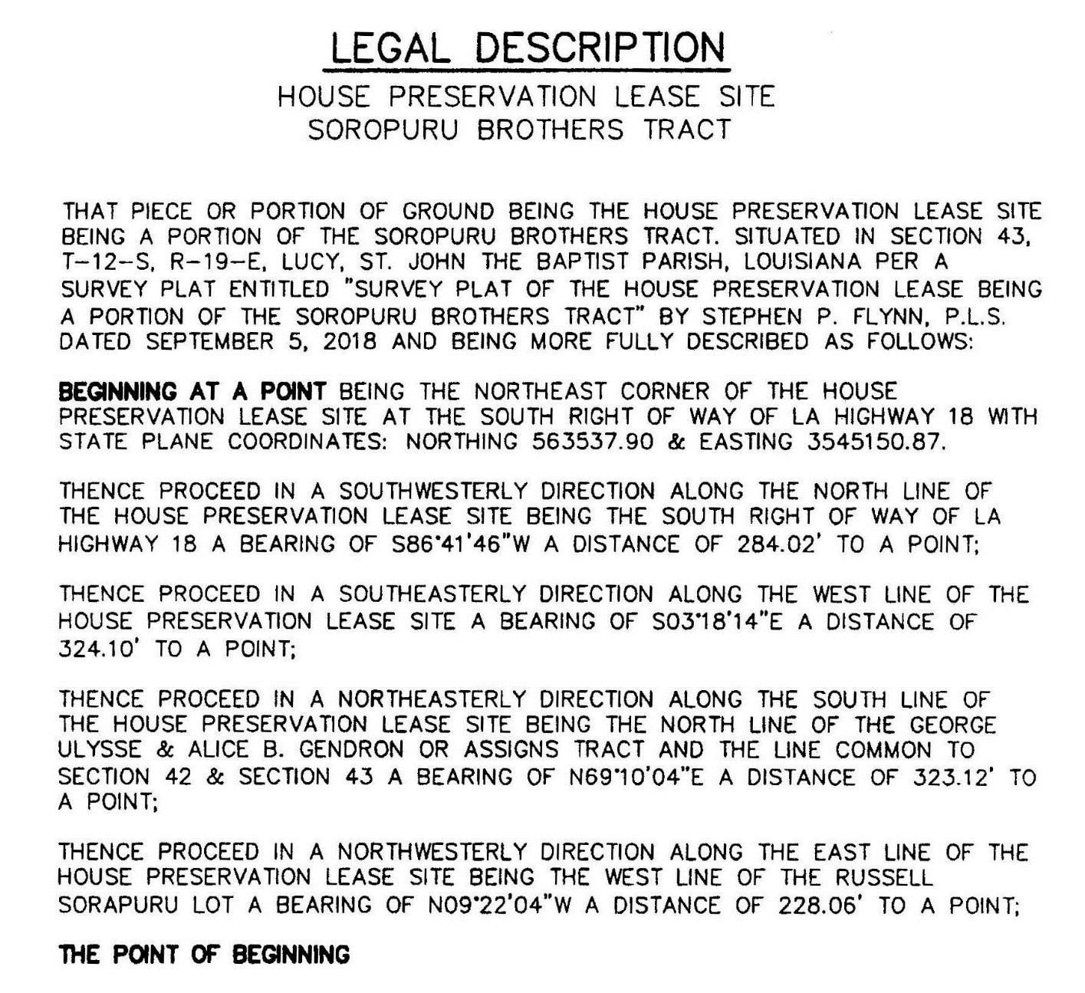
particularly described as:

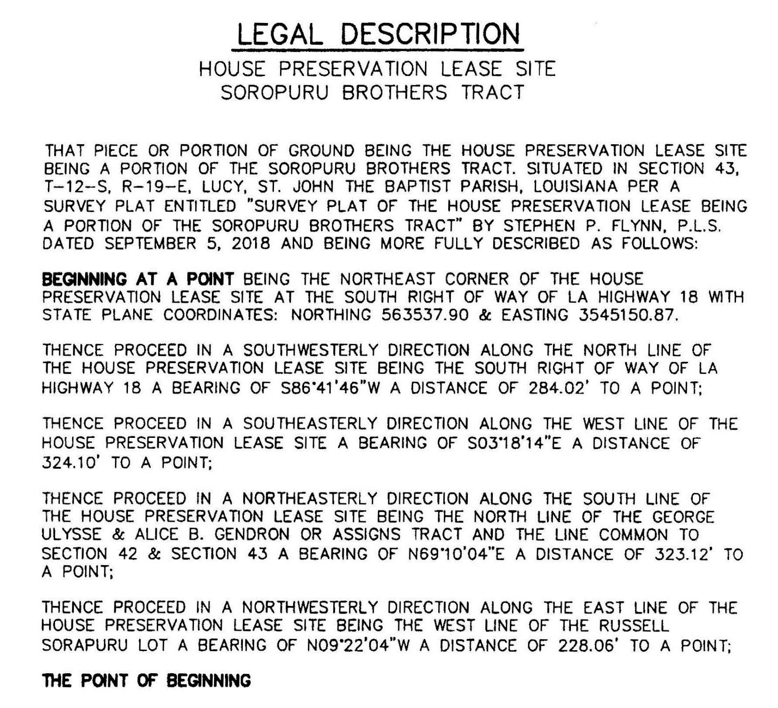
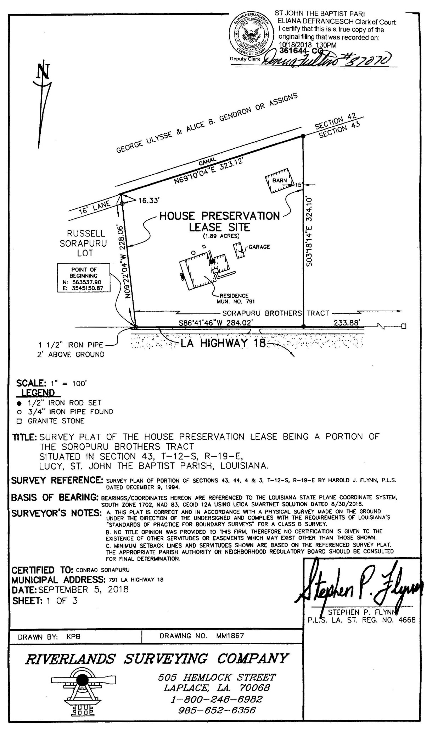
EXHIBIT B -
Baseline Documentation of Structure, Site and Features – St. John the Baptist Parish, Lucy, 971 LA Hwy 18
Date: July 2018

PHOTO KEYMAP (Not To Scale):
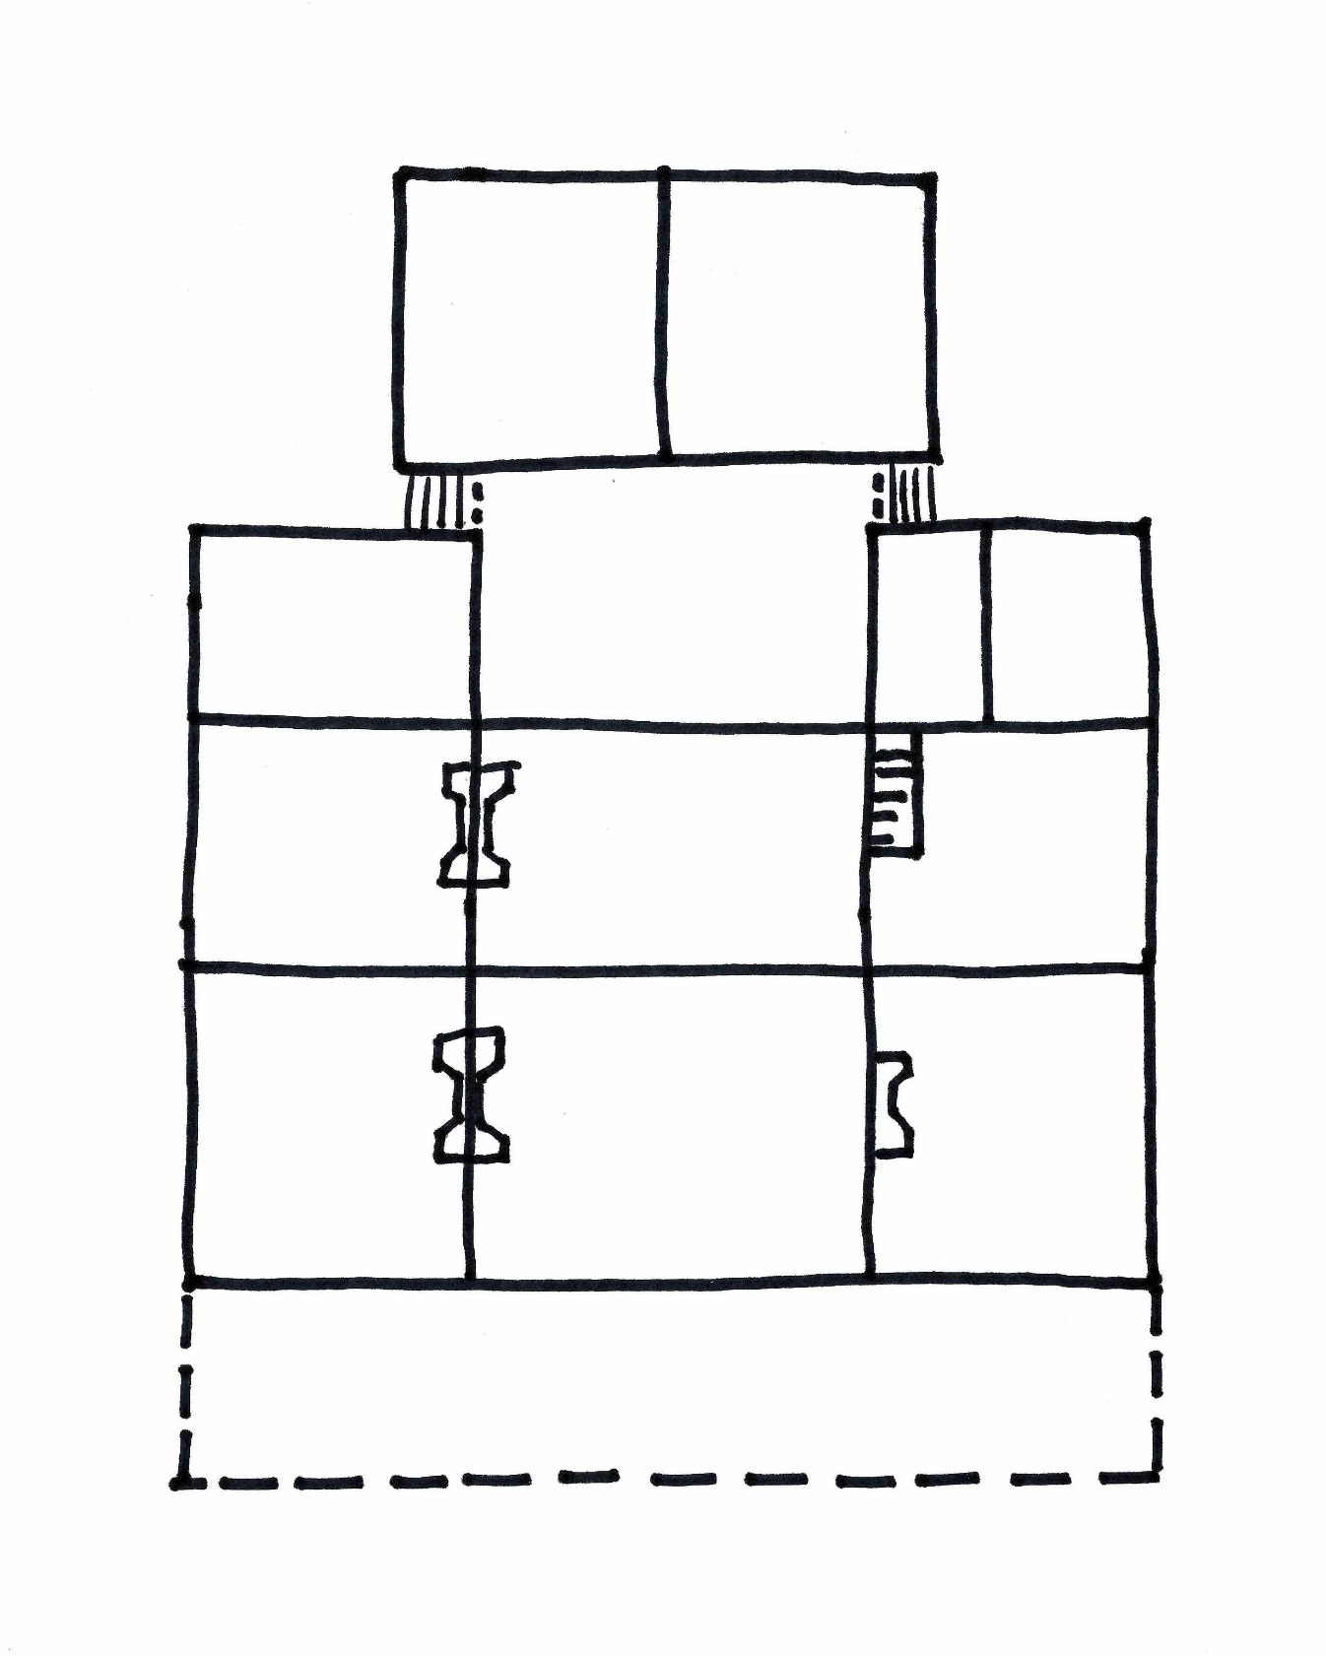
Setting& Exterior:
NOTE: Photos 36-39 are typical details.
043
044
045
Kitchen - South
042
Bedroom
041
040
Bedroom
Dining Room
034, 035
032
033
Bath
031
030
029
Back Porch
Bath
028
011
027
025
Bedroom
026
024
023
Bedroom
022
019,021
018, 020
016, 017
013
015
Front Porch
014
012
010
009
001, 008
007
002
003
004
006
0052
North
(River)
Parlor
Kitchen - North
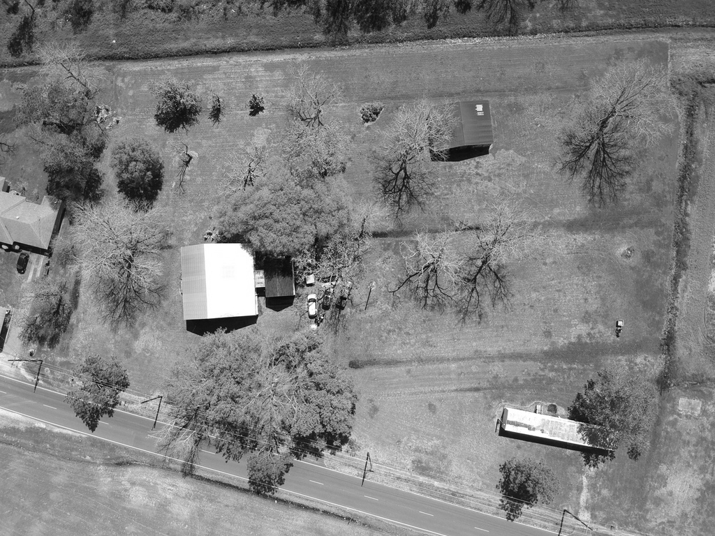

Photo No. : 001
Description: Aerial view of site looking south, with LA Hwy 18 at bottom of photo and Mississippi River behind.

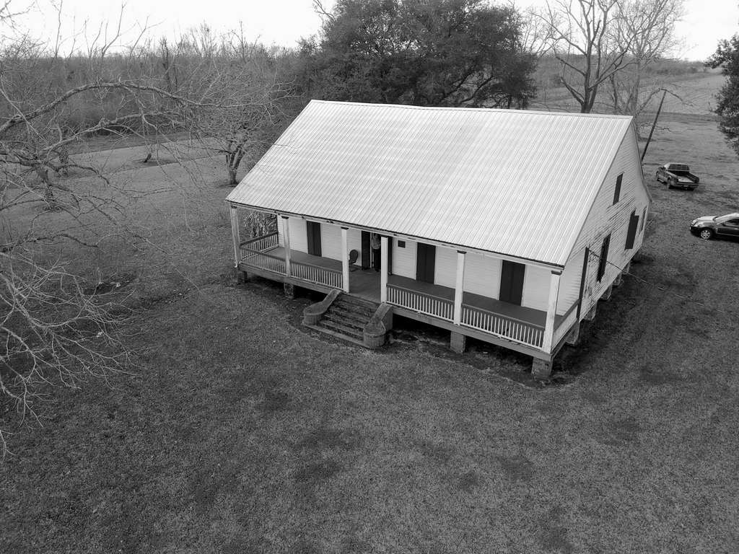

Photo No. : 002
Description: Looking Southwesttoward front of house.

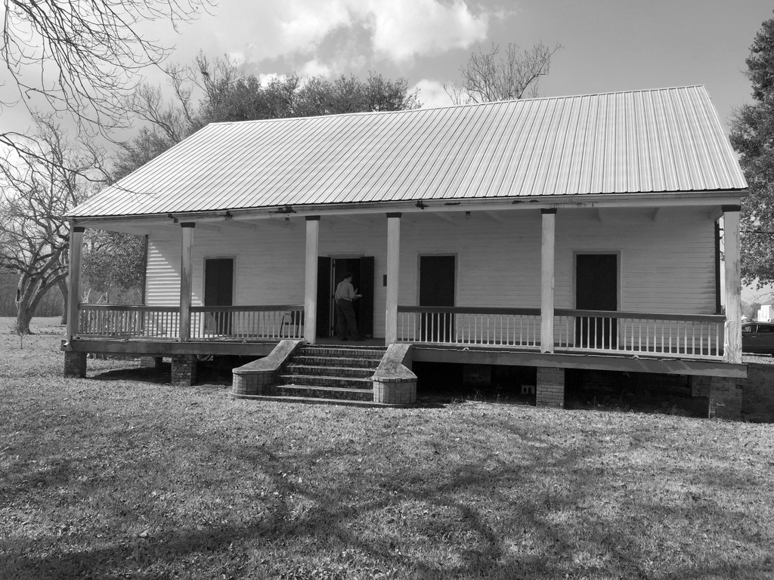

Photo No. : 003
Description: Looking West toward front of house.

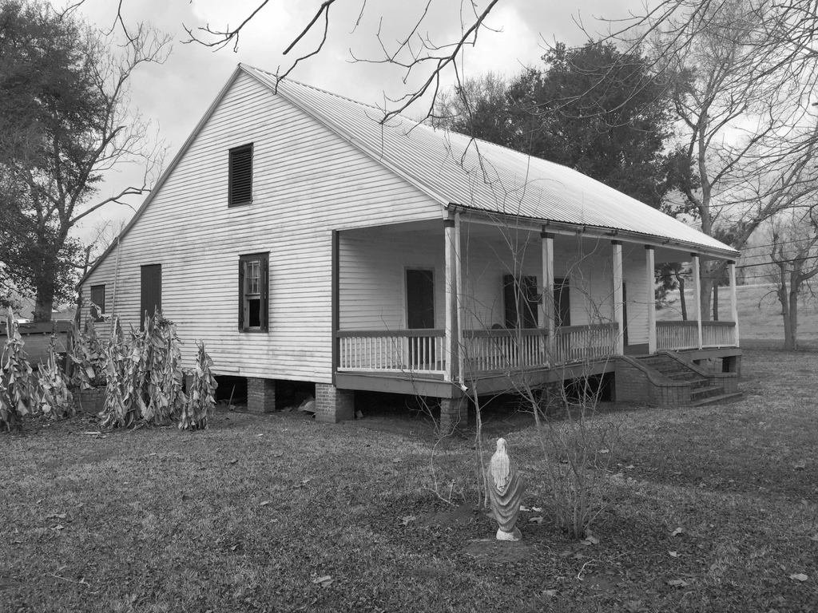

Photo No. : 004
Description: Looking Northwest toward front of house.

Some Photo Pages omitted for brevity.
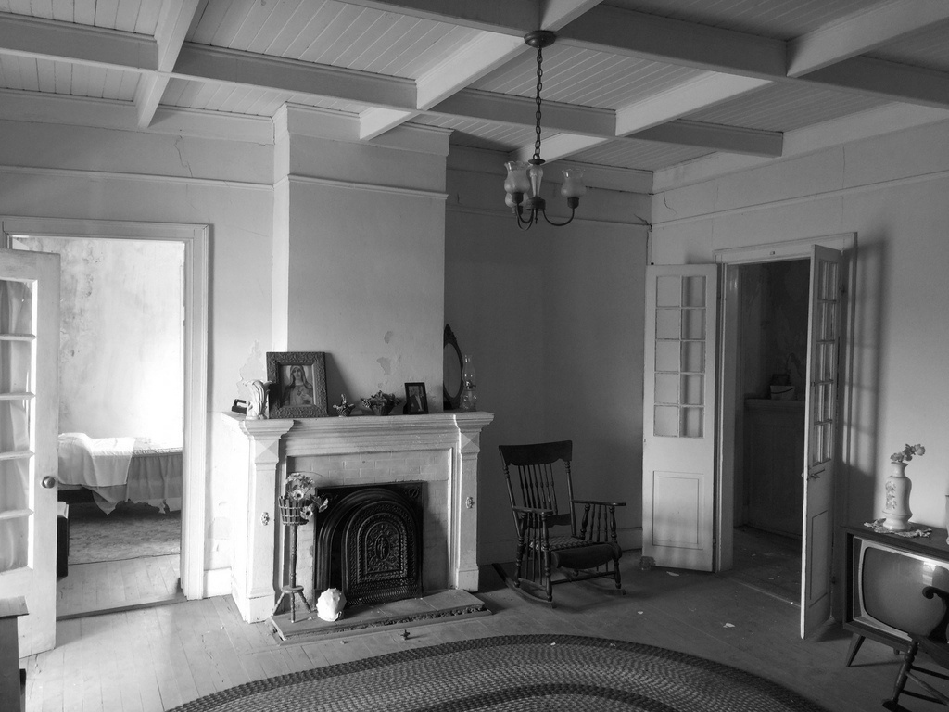

Photo No. : 017
Parlor showing fireplace, coffered ceiling, doors and trim.

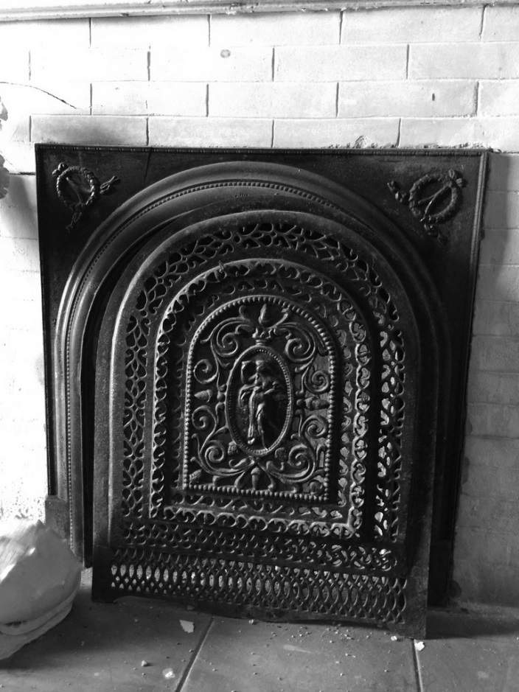
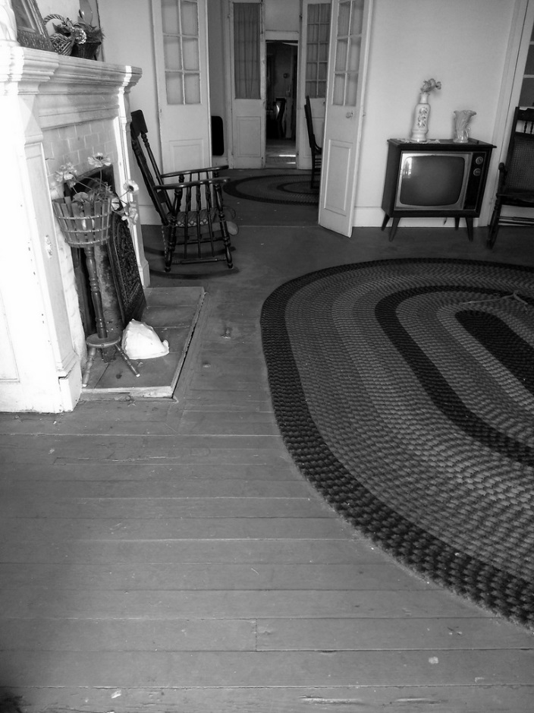

Photo No. : 018 Photo No. : 019
Detail of flooring and mantel in parlor. Detail of decorative metal grate at parlor fireplace.

EXHIBIT C
SECRETARY OF THE INTERIOR'S STANDARDS FOR THE TREATMENT OF HISTORIC PROPERTIES(1992)
TREATMENTS
There are Standards for four distinct, but interrelated, approaches to the treatment of historic properties -- Preservation, Rehabilitation, Restoration, and Reconstruction. Preservation focuses on the maintenance and repair of existing historic materials and retention of a property’s form as it has evolved over time. (Protection and Stabilization have now been consolidated under this treatment.) Rehabilitation acknowledges the need to alter or add to a historic property to meet continuing or changing uses while retaining the property’s historic character. Restoration is undertaken to depict a property at a particular period of time in its history, while removing evidence of other periods. Reconstruction re-creates vanished or non-surviving portions of a property for interpretive purposes.
In summary, the simplification and sharpened focus of these revised sets of treatment standards is intended to assist users in making sound historic preservation decisions. Choosing appropriate treatment for a historic property, whether preservation, rehabilitation, restoration, or reconstruction, is critical. This choice always depends on a variety of factors, including the property’s historical significance, physical condition, proposed use, and intended interpretation.

Preservation is defined as the act or process of applying measures necessary to sustain the existing form, integrity, and materials of a historic property. Work, including preliminary measures to protect and stabilize the property, generally focuses upon the ongoing maintenance and repair of historic materials and features rather than extensive replacement and new construction. New exterior additions are not within the scope of this treatment; however, the limited and sensitive upgrading of mechanical, electrical, and plumbing systems and other code-required work to make properties functional is appropriate within a preservation project.

STANDARDS FOR PRESERVATION
1. A property shall be used as it was historically, or be given a new use that maximizes the retention of distinctive materials, features, spaces, and spatial relationships. Where a treatment and use have not been identified, a property shall be protected and, if necessary, stabilized until additional work may be undertaken.
2. The historic character of the property shall be retained and preserved. The replacement of intact or repairable historical materials or alteration of features, spaces, and spatial relationships that characterize a property shall be avoided.
3. Each property shall be recognized as a physical record of its time, place, and use. Work needed to stabilize, consolidate, and conserve existing historic materials and features shall be physically and visually compatible, identifiable upon close inspection, and properly documented for future research.
4. Changes to a property that have acquired historic significance in their own right shall be retained and preserved.
5. Distinctive materials, features, finishes, and construction techniques or examples of craftsmanship that characterize a property shall be preserved.
6. The existing condition of historic features shall be evaluated to determine the appropriate level of intervention needed. Where the severity of deterioration requires repair or limited replacement of a distinctive feature, the new material shall match the old in composition, design, color, and texture.
7. Chemical or physical treatments, if appropriate, shall be undertaken using the gentlest means possible. Treatments that cause damage to historic materials shall not be used.
8. Archeological resources shall be protected and preserved in place. If such resources must be disturbed, mitigation measures shall be undertaken.
PRESERVATION AS A TREATMENT
When the property’s distinctive materials, features, and spaces are essentially intact and thus convey the historic significance without extensive repair or replacement; when depiction at a particular period of time is not appropriate; and when a continuing or new use does not require additions or extensive alterations, Preservation may be considered as a treatment. Prior to undertaking work, a documentation plan should be developed.

REHABILITATION is defined as the act or process of making possible a compatible use for a property through repair, alterations, and additions while preserving those portions or features which convey its historical, cultural, or architectural values.
STANDARDS FOR REHABILITATION
1. A property shall be used as it was historically or be given a new use that requires minimal change to its distinctive materials, features, spaces, and spatial relationships.
2. The historic character of a property shall be retained and preserved. The removal of distinctive materials or alteration of features, spaces, and spatial relationships that characterize a property shall be avoided.
3. Each property shall be recognized as a physical record of its time, place, and use. Changes that create a false sense of historical development, such as adding conjectural features or elements from other historic properties, shall not be undertaken.
4. Changes to a property that have acquired historic significance in their own right shall be retained and preserved.
5. Distinctive materials, features, finishes, and construction techniques or examples of craftsmanship that characterize a property shall be preserved.
6. Deteriorated historic features shall be repaired rather than replaced. Where the severity of deterioration requires replacement of a distinctive feature, the new feature shall match the old in design, color, texture, and, where possible, materials. Replacement of missing features shall be substantiated by documentary and physical evidence.
7. Chemical or physical treatments, if appropriate, shall be undertaken using the gentlest means possible. Treatments that cause damage to historic materials shall not be used.
8. Archeological resources shall be protected and preserved in place. If such resources must be disturbed, mitigation measures shall be undertaken.
9. New additions, exterior alterations, or related new construction shall not destroy historic materials, features, and spatial relationships that characterize the property. The new work shall be differentiated from the old and shall be compatible with the historical materials, features, size, scale, and proportion, and massing to protect the integrity of the property and its environment.
10. New additions and adjacent or related new construction shall be undertaken in such a manner that, if removed in the future, the essential form and integrity of the historic property and its environment would be unimpaired.
REHABILITATION AS A TREATMENT
When repair and replacement of deteriorated features are necessary; when alterations or additions to the property are planned for a new or continued use; and when its depiction at a particular period of time is not appropriate, Rehabilitation may be considered as a treatment. Prior to undertaking work, a documentation plan for Rehabilitation should be developed.

RESTORATION is defined as the act or process of accurately depicting the form, features, and character of a property as it appeared at a particular period of time by means of the removal of features from other periods in its history and reconstruction of missing features from the restoration period. The limited and sensitive upgrading of mechanical, electrical, and plumbing systems and other code-required work to make properties functional is appropriate within a restoration project.
STANDARDS FOR RESTORATION
1. A property shall be used as it was historically or be given a new use which reflects the property’s restoration period.
2. Materials and features from the restoration period shall be retained and preserved. The removal of materials or alteration of features, spaces, and spatial relationships that characterize the period shall not be undertaken.
3. Each property shall be recognized as a physical record of its time, place, and use. Work needed to stabilize, consolidate, and conserve materials and features from the restoration period shall be physically and visually compatible, identifiable upon close inspection, and properly documented for future research.
4. Materials, features, spaces, and finishes that characterize other historical periods shall be documented prior to their alteration or removal.
5. Distinctive materials, features, finishes, and construction techniques or examples of craftsmanship that characterize the restoration period shall be preserved.
6. Deteriorated features from the restoration period shall be repaired rather than replaced. Where the severity of deterioration requires replacement of a distinctive feature, the new feature shall match the old in design, color, texture, and where possible, materials.
7. Replacement of missing features from the restoration period shall be substantiated by documentary and physical evidence. A false sense of history shall not be created by adding conjectural features, features from other properties, or by combining features that never existed together historically.
8. Chemical or physical treatments, if appropriate, shall be undertaken using the gentlest means possible. Treatments that cause damage to historic materials shall not be used.

9. Archeological resources affected by a project shall be protected and preserved in place. If such resources must be disturbed, mitigation measures shall be undertaken.
10. Designs that were never executed historically shall not be constructed.
RESTORATION AS A TREATMENT
When the property’s design, architectural, or historical significance during a particular period of time outweighs the potential loss of extant materials, features, spaces, and finishes that characterize other historical periods; when there is substantial physical and documentary evidence for the work; and when contemporary alterations and additions are not planned, Restoration may be considered as a treatment. Prior to undertaking work, a particular period of time, i.e., the restoration period, should be selected and justified, and a documentation plan for Restoration developed.

RECONSTRUCTION is defined as the act or process of depicting, by means of new construction, the form, features, and detailing of a non-surviving site, landscape, building, structure, or object for the purpose of replicating its appearance at a specific period of time and in its historic location.
STANDARDS FOR RECONSTRUCTION
1. Reconstruction shall be used to depict vanished or non-surviving portions of a property when documentary and physical evidence is available to permit accurate reconstruction with minimal conjecture, and such reconstruction is essential to the public understanding of the property.
2. Reconstruction of a landscape, building, structure, or object in its historic location shall be preceded by a thorough archeological investigation to identify and evaluate those features and artifacts which are essential to an accurate reconstruction. If such resources must be disturbed, mitigation measures shall be undertaken.
3. Reconstruction shall include measures to preserve any remaining historic materials, features, and spatial relationships.
4. Reconstruction shall be based on the accurate duplication of historic features and elements substantiated by documentary or physical evidence rather than on conjectural designs or the availability of different features from other historic properties. A reconstructed property shall re-create the appearance of a non-surviving historic property in materials, design, color, and texture.
5. A reconstruction shall be clearly identified as a contemporary re-creation.
6. Designs that were never executed historically shall not be constructed.
RECONSTRUCTION AS A TREATMENT
When a contemporary depiction is required to understand and interpret a property’s historic value (including the re-creation of missing components in a historic district or site); when no other property with the same associative value has survived; and when sufficient historical documentation exists to ensure an accurate reproduction, Reconstruction may be considered as a treatment. Prior to undertaking work, a documentation plan for Reconstruction should be developed.

